OCR English Literature

A Level

Bridging the gap from Y11 to Y12
Name: _________________

Welcome to A Level English Literature!

OCR English Literature A Level:
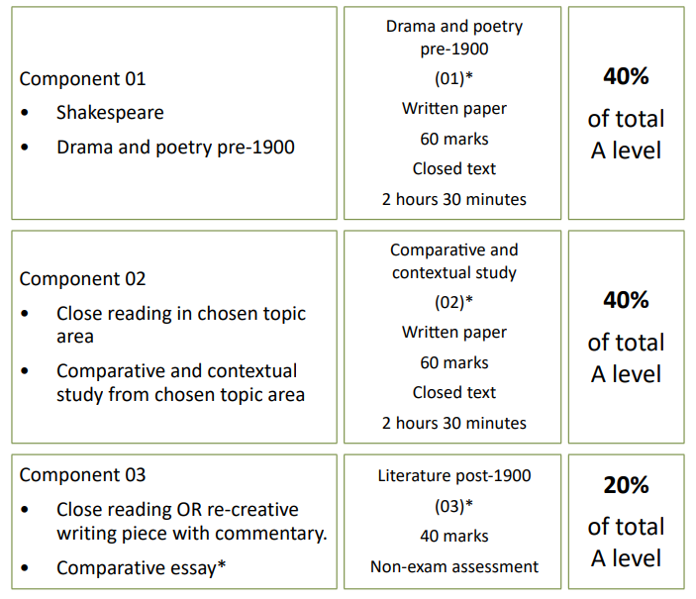
Component 1 | Component 2 | Component 3
- The Tempest  - Paradise Lost  - The Duchess of Malfi | The Gothic  - Dracula  - The Picture of Dorian Gray | Either:  - The Ferryman OR The History Boys  Then:  - Dubliners  - T. S. Eliot Poetry

Research
Text | Summary | Key Info (e.g. context) | Thoughts?
The Tempest
Paradise Lost
The Duchess of Malfi
Dracula
The Picture of Dorian Gray

The Tempest: Extract Analysis
In this extract, Miranda, Prospero’s daughter, is concerned about the recent storm and its consequences.
Annotate the extract considering the following potential prompts: power/ relationships/ family/ loyalty.
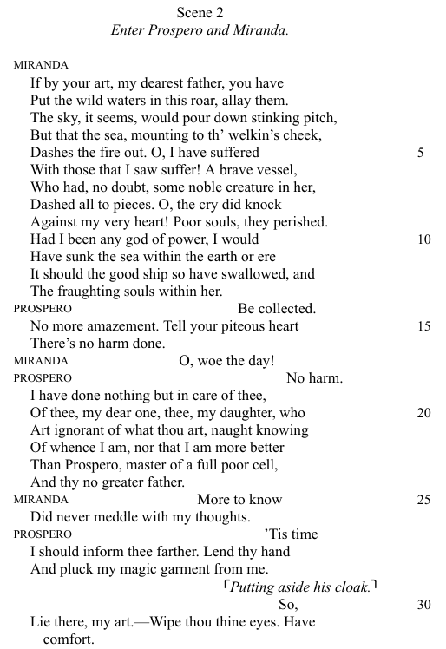

Paradise Lost: Annotate the artwork below considering your thoughts/ opinions on the following:
- Power
- Influence
- Gender
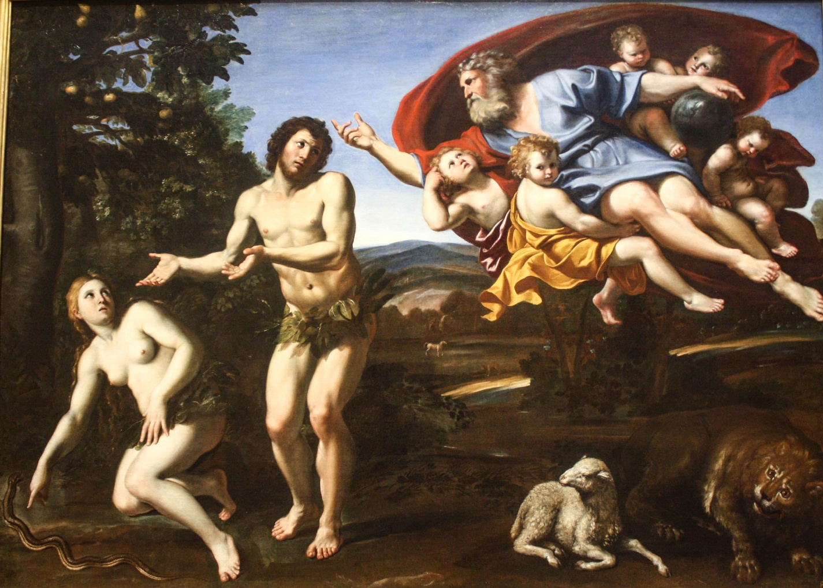
- Colour symbolism

How might this relate to your research about ‘Paradise Lost’?

The Duchess of Malfi:
“Is it possible to have power and freedom at the same time?”
Complete the table below by considering your existing ideas/ knowledge of Jacobean culture.

Yes | No

Dracula: Annotate the extract about Dracula’s appearance and produce an image to match the description.
His face was a strong, a very strong, aquiline, with high bridge of the thin nose and peculiarly arched nostrils, with lofty domed forehead, and hair growing scantily round the temples but profusely elsewhere. His eyebrows were very massive, almost meeting over the nose, and with bushy hair that seemed to curl in its own profusion. The mouth, so far as I could see it under the heavy moustache, was fixed and rather cruel-looking, with peculiarly sharp white teeth. These protruded over the lips, whose remarkable ruddiness showed astonishing vitality in a man of his years. For the rest, his ears were pale, and at the tops extremely pointed. The chin was broad and strong, and the cheeks firm though thin. The general effect was one of extraordinary pallor.
Hitherto I had noticed the backs of his hands as they lay on his knees in the firelight, and they had seemed rather white and fine. But seeing them now close to me, I could not but notice that they were rather coarse, broad, with squat fingers. Strange to say, there were hairs in the centre of the palm. The nails were long and fine, and cut to a sharp point. As the Count leaned over me and his hands touched me, I could not repress a shudder. It may have been that his breath was rank, but a horrible feeling of nausea came over me, which, do what I would, I could not conceal.
The Count, evidently noticing it, drew back. And with a grim sort of smile, which showed more than he had yet done his protruberant teeth, sat himself down again on his own side of the fireplace. We were both silent for a while, and as I looked towards the window I saw the first dim streak of the coming dawn. There seemed a strange stillness over everything.
Your thoughts on the character description?
Character Drawing:

The Picture of Dorian Gray: Moral Dilemmas

Read the statements then position yourself on the continuum line and explain your reasoning.
“Beauty is more important than morality.”
Disagree
Agree

“You should live for pleasure, no matter the consequences.”
Disagree
Agree

“Art should have no moral purpose.”
Disagree
Agree

How does this relate to your research of the text?

Other Tasks:
- Research the Gothic genre’s creation and conventions.

- Read some modern Gothic literature e.g. Stephen King.

- Create a list of literary close analysis techniques based on your GCSE knowledge.

- Consider how writers might present the following “big ideas”:
  - Power
  - Identity
  - Corruption
  - Love
  - Isolation

- Create your own analytical paragraph writing guide for yourself based on your GCSE structure – use the internet to research the assessment objectives and explore how these might be applied at A Level.

