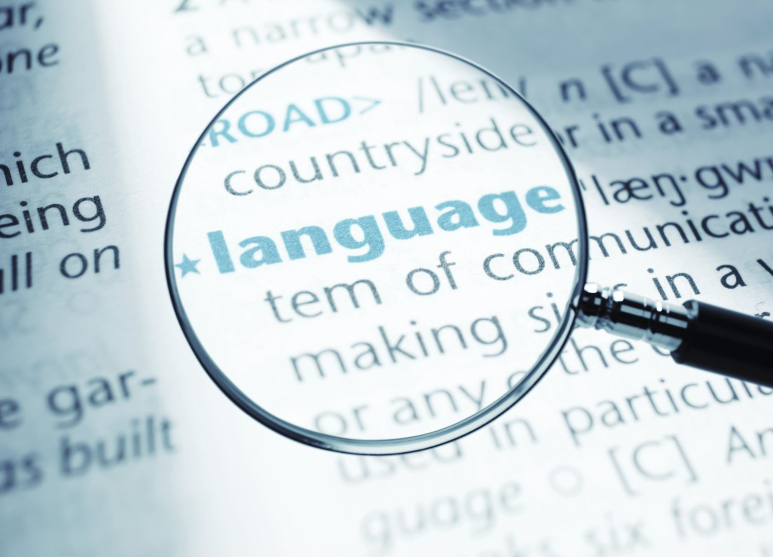

English Language:
Bridging the Gap from GCSE to A Level

Section 1: Language and You
One of the most interesting aspects of studying language is that you learn more about your own language use, so let’s make this first task all about you…
Create a ‘language profile’ of yourself by answering the following questions and then writing them up as a set of bullet points that highlight what you think are the most interesting and important aspects of the language you use:
- What is your earliest memory of language? Do you remember any nursery rhymes, songs, stories, or picture books from when you were very young?
- Do your family members have any recordings, videos, photographs, or stories about the first words you said?
- Have you kept any old pieces of schoolwork from when you were first learning to read and write?
- Where were you born, and where do your family members come from? Are there any languages, dialects, or accents in your family that have influenced the way you speak?
- Are there any words, phrases, or sayings that are unique to your family or friendship group that other people might not understand?
- Do you notice any differences between the way you and your friends speak and the way other people around you speak, such as teachers, parents, or students in other year groups?
- Are there any people you watch, listen to, or follow online whose use of language you find particularly interesting, entertaining, or irritating?
- Have you ever come across a word, phrase, accent, or style of speaking that felt completely unfamiliar or unusual to you?
- Have your parents, carers, teachers, or other family members ever commented on the way you speak or use language? What did they say?
You should also consider:
- What experiences have shaped the way you use language today?
- How has your family background influenced your vocabulary, accent, or way of communicating?
- Can you identify any language features that mark you as part of a particular social, regional, or cultural group?
- How aware are you of changing the way you speak in different situations and with different people?
- What examples of language use in everyday life have made you think about how language works?

Language profile

Section 2: An Ever-Changing Language
The English language is always generating new words. New words can be created out of nothing (neologisms) or be formed by using other words – or parts of words – together in new combinations (what are called compounds and blends). Sometimes initials of words in a phrase might be used (acronyms and initialisms) and you might also see parts of words being added to the front or end of another word to give it a new form (prefixes and suffixes).
Look at the list of some of the new words that have appeared (or suddenly become much more popular) in English over the last few years.
- Have you heard of these words before? Have you used any of them? Define the terms you are familiar with and tick the relevant boxes for each word.
- Choose two words from the list that you think are an important addition to the language. Try to come up with a sentence or two explaining why they are so important.
- Choose two words from the list that you think are pointless and insignificant. What’s the problem with these words and why do you think they shouldn’t be include? Again, write a sentence or two explaining your thinking.

Word | Definition | Have seen/heard this word used | Have used this word myself
ate (and left no crumbs)
aura
cooked
delulu
doomscroll
FYP
goat(ed)
ick
rizz
simp
sigma
looksmaxxing
lowkey
mid

Important additions to the English Language:
Word 1: __________________________
Explanation:
____________________________________________________________________________________________________________________________________________________________________________________________________________

Word 2: __________________________
Explanation:
____________________________________________________________________________________________________________________________________________________________________________________________________________

Insignificant additions to the English Language:
Word 1: __________________________
Explanation:
____________________________________________________________________________________________________________________________________________________________________________________________________________

Word 2: __________________________
Explanation:
____________________________________________________________________________________________________________________________________________________________________________________________________________

Section 3: Writing About a Topical Language Issue
The way we talk and write is constantly changing, and people often have strong opinions about whether those changes are good or bad. Some argue that new technologies are reshaping how we communicate, while others worry that certain habits (like using slang, dropping punctuation, or relying on emojis) might be weakening traditional standards. You’ll also find debates about accents, identity, and whether some ways of speaking are treated more fairly than others. When you write about a topical language issue, you explore these discussions, look at different viewpoints, and explain your own position clearly and confidently.

“Slang is ruining the English language.”

Write 150 words giving your view.
You should include:
- A clear opinion (you may address opposing perspectives, but make it clear which side of the debate you are on)
- At least one example
- A confident, engaging tone
  - Do you want to sound like you are writing an article? Could you perhaps write it as if you were speaking on a podcast?
____________________________________________________________________________________________________________________________________________________________________________________________________________
____________________________________________________________________________________________________________________________________________________________________________________________________________
____________________________________________________________________________________________________________________________________________________________________________________________________________
____________________________________________________________________________________________________________________________________________________________________________________________________________
____________________________________________________________________________________________________________________________________________________________________________________________________________
____________________________________________________________________________________________________________________________________________________________________________________________________________
____________________________________________________________________________________________________________________________________________________________________________________________________________
____________________________________________________________________________________________________________________________________________________________________________________________________________
____________________________________________________________________________________________________________________________________________________________________________________________________________
____________________________________________________________________________________________________________________________________________________________________________________________________________
____________________________________________________________________________________________________________________________________________________________________________________________________________
____________________________________________________________________________________________________________________________________________________________________________________________________________

Section 4: Comparing and Contrasting Texts
When we read different texts about the same topic, we often notice that each one presents the subject in its own way. A writer might choose a formal style to sound authoritative, while another might use a more casual voice to feel friendly or relatable. Some texts aim to inform, others to persuade, and some simply want to share an opinion or express a feeling. By comparing and contrasting texts, we look closely at how writers shape their messages through tone, word choices, and the way they address their audience. This helps us understand not just what each text says, but how and why it communicates its ideas differently.
Read the two extracts then complete the table that follows. You will need to be able to identify the following in both texts:
- Genre – the ‘type’ of text
- Register – how formal is the text?
- Audience – who do you think this text is aimed at?
- Mode – is the text written or spoken?
- Purpose – what is the purpose of each text? What are the text producers aiming to achieve?
Text A: An extract of a transcript from the podcast ‘Code Switch’, where hosts discuss how race factors into everyday interactions. In this episode, hosts Gene Demby and B. A. Parker (with American linguist Adam Aleksic) explore “Gen-Z slang” and its contribution to incel culture. The podcast aired May 27th 2026. American English spellings have been left in for authenticity.
PARKER: So then, like, what is the impact of incel vocab on our culture?
ALEKSIC: Yeah. I think there is perhaps a dangerous rhetoric that atomizes society in a way that you can optimize, that there are these discrete categories that you can put people into, either incel or, you know, looksmaxxer or chud or - the fact that you can put people into buckets, I think, is a very dangerous idea. I think language itself does this. So I have some qualms with even the spoken word, I suppose, but a lot of the incel ideology pushes the idea that we can be reduced to these base units. And then from those units, there is an objective, oh, if you have positive canthal tilt, which is the shape, like, that your eyes are facing, that that is more attractive, or if you have this kind of jawline that is more attractive. And it doesn't really recognize the subjectivity and the variance that exists in the human condition.
PARKER: So for a long time, like, we've used phrases like cakewalk or long time no see, which, like - and more recently, like, maxxing. Like, all these terms have problematic origins. What does it mean when we adopt vocabulary with racist and eugenicist roots into mainstream culture?
ALEKSIC: Yeah. Yeah. There's one argument that, you know, nobody thinks about long time no see anymore, which comes out of mocking Chinese Pidgin English. And if nobody uses it, nobody thinks about it that way, and people are using it as this, like, kind of expression between themselves. It's sort of like using maxxing for - whimsymaxxing or something.
PARKER: Yeah.
ALEKSIC: It is good, I think, to be aware of this stuff and be aware of when words have the potential to hurt people. It's possible some people are hurt by long time no see. Once I found out the origin of the word, I kind of stopped using it because there are many alternatives, but I don't think it's - and I think a problem with - a lot of people are feeling is the sense that your language is being policed. Ideally, if, you know, we all just are thoughtful about it, we end up choosing the kinder option and we think about what we're saying. But yeah, there's sort of that tension as well.
PARKER: Fingers crossed, man (laughter).

Spoken vs Written Texts:
Other than the fact that this is a transcript from a podcast, how do you know that this is a spoken text? What features of spoken language do you recognise?
____________________________________________________________________________________________________________________________________________________________________________________________________________
____________________________________________________________________________________________________________________________________________________________________________________________________________

Text B: An extract of an article from the American Psychological Association titled ‘The psychology of why we use slang’. The article was published April 1st 2026. American English spellings have been left in for authenticity.
Young people are often the key creators and innovators of slang because they use language as a way to define themselves and draw boundaries between their own group and perceived outsiders. Slang is a creative way for them to demonstrate how their social world feels different from that of their parents or other adults. Slang use contributes to self-definition, peer bonding, and even theory of mind—the understanding that others have intentions, desires, beliefs, perceptions, and emotions different from one’s own that affect their actions and behaviors.
The motivation to signal in-group identity via slang can be potent, according to Robert Hawkins, PhD, a cognitive scientist and an assistant professor of linguistics at Stanford University. “Slang is doing two things at once. When you say something your friends understand and your parents don’t, you’re communicating content—like whether something’s cool or not—but you’re also communicating who you are.” In a series of controlled experiments, Alicia Chen, a fourth-year PhD student in the department of brain and cognitive sciences at the Massachusetts Institute of Technology (MIT), Rebecca Saxe, PhD, an MIT professor of cognitive neuroscience, and Hawkins found that when individuals want to signal membership in a group, they prefer concise, group-specific terms even at the cost of not being understood by outsiders

 | Text A | Text B
Genre
Register
Audience
Mode
Purpose

Section 5: Language Under the Microscope
When we look closely at a piece of writing, we start to notice the small choices that shape how it sounds and what it makes us think or feel. A writer might choose short, sharp sentences to create urgency, or longer, more detailed ones to sound thoughtful and deliberate. Certain words can make a text feel friendly or formal, while others are chosen to persuade, reassure, or provoke a reaction. Even the way a text is organised (from its opening line to its final message) helps guide the reader’s response. Studying language “under the microscope” means paying attention to these details and exploring how they work together to create meaning.
Complete the table to familiarise yourself with some of the key terminology that you will need to be confident using when closely analysing lexis and semantics (words and their meanings) and grammar and syntax (the system and structure of a language and word order).

Feature | Definition | Example
Concrete noun
Abstract noun
Collective noun
Proper noun
Pronoun
Past participle verb
Present participle verb
Modal verb
Base form adjective
Comparative adjective
Superlative adjective
Process adverb
Spatial adverb
Temporal adverb
Definite article
Indefinite article
Noun phrase
Participle phrase
Main/independent clause
Subordinate/dependent clause
Coordinating conjunction
Subordinating conjunction
Simple sentence
Compound sentence
Complex sentence

The following is an extract from an article published by The Guardian on 12th June 2026. The article discusses the UK Government's plan to restrict access to certain social media platforms for under-16s.
Using the terminology from the previous table, explore how lexis and grammar are used in the text.
How do the techniques that you identify contribute to the construction of meanings?
Use the space around the extract to annotate your ideas.

Teenagers under the age of 16 are to be banned from accessing “high-risk” social media apps while safer platforms will be subjected to restrictions, under a sweeping government crackdown.
Under-18s will also be banned from using romantic or sexual AI chatbots after a consultation on keeping children safe online.
However, sources warned the government faced the threat of judicial review over its decision to ban some platforms and not others. Keir Starmer is to outline the plans on Monday but ministers will set out which specific platforms face an under-16 ban at a later date.
The measures to be announced by the prime minister include restrictions on “safe” social media apps, meaning under-16s will be banned from receiving or using disappearing messages, chats with adult strangers, and livestreaming.
The turnaround has been rapid, with the government setting out its response less than a fortnight after the consultation closed on 2 June. The government received more than 116,000 responses to the consultation and nine out of 10 parents expressed support for an under-16 ban.

