
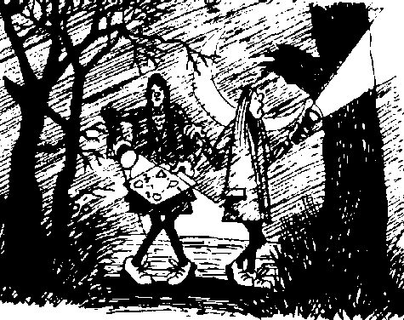
Thomas Telford School

“ O Lordy”
Arrangements for Gold/Extra/Direct Training Expedition 2026

This training expedition is for those students following the
Gold Direct/Gold Additional Training Programme.

Dates – Kit issue – Tuesday 5th May, Session 3.
Day One – Thursday 14th May, meet TTS 10.0am.
Day Two – Friday 15th May, return TTS 1.0pm.
Kit return – To be confirmed.

You will be dropped off at your start point and you will walk to your camp site, this will be a partly accompanied teaching day.

You need to supply your own:-
Tent pegs (Total 16 per tent).
Gas for stoves.
Compass.
You will need to bring with you: -
Kit as already issued on Checklist for backpacking. (also see TTS web site)
Lunches for Day 1 and Day 2.
Meal to cook as planned on evening of day 1.
Breakfast for Day 2.
Drinks/Water for Day 1.

EMERGENCY CONTACT NUMBER – Mr Baker 07815 947114.

Please see TTS Home Page/Sport Tweet site in the event of unforeseen problems extreme weather/ cancellation.
Adventure Challenge Motivation Teamwork Building Fear Hope Success Failure Wet Cold Hungry Risk
Frightening New places Wild Quiet Imagination Relevance Frustration Confidence Fragile Safe Bad Caring Empathy Sharing Strive Shy
Action Fun Risk Planning Friendships Problem solving Learning for life Thinking under pressure Making real decisions Facing consequences Overcoming Confidence
Happy Sad Fear Hope Reality Stress Wicked Rain Alone Together Open space Experiences

