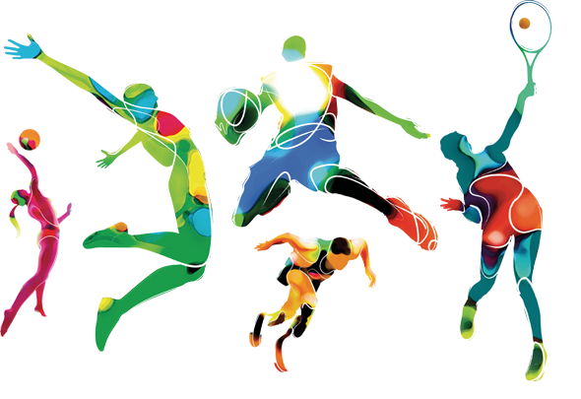
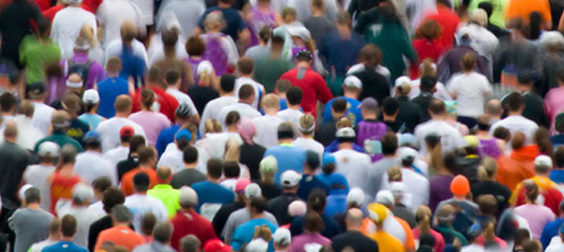
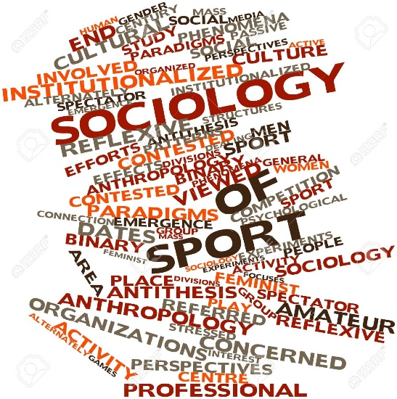

The Sociology of Sport
Workbook



NAME:

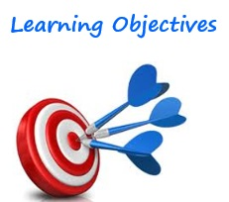
Self-assessment:
(to be done at the end!)

After studying this topic, you should be able to:

Objective | Complete?
- Define the key terms related to sport and society;
- Society
- Equal opportunities
- Discrimination
- Stereotypes
- Prejudice
- Explain the key terms in relation to their study of sport & their impact on equal opportunities in sport and society:
- Socialisation
- Social control
- Social change
- Social issues
- Inequality
- Social stratification
- Apply social action theory to social issues in physical activity & sport

What is sociology?

Sociology aims to answer 2 key questions:
- How do people ____________________________________________________________________________________________________________________?
- How does ____________________________________________________________________________________________________________________?


In what ways might sociology be useful then in examining sport?? …


What is the sociology of sport?

The sociology of sport:
- Considers the relationship between ______________________
- Examines the ___________________ occurring within sport
- Looks at how _______________________
Can be overcome

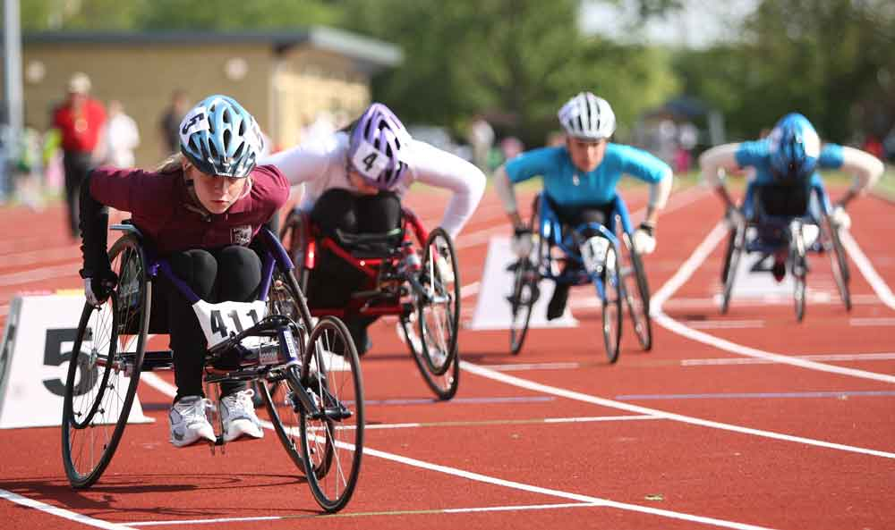
During this topic we will define the following key terms and apply them to sport;
- Society
- Socialisation
- Primary socialisation
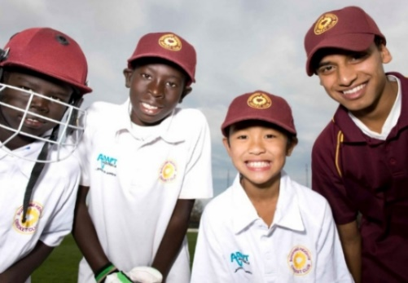
- Secondary socialisation
- Social processes
- Social control
- Social change
- Social issues
STUDY TIP = It is important that you ask yourself every time you learn about one of these concepts
‘How does this apply to equality of sporting opportunities?’
- Social structures
- Social stratification
- Social class

Society
Define it:

Draw a picture that sums up the definition:

How does this apply to sport?

Give 3 examples of when success in sport has boosted a society’s sense of pride and identity:
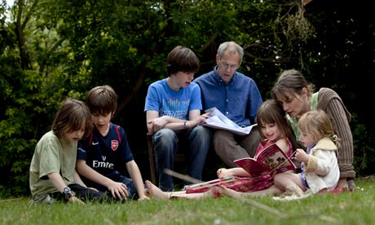
Socialisation
Define it:

Draw 2 diagrams for the 2 parts to socialisation:
1. | 2.


Play is a good way good way to learn how to share, interact and practise becoming an adult.
Task = Think about and write down the various purposes of play during the primary socialisation process.
- What skills/values do children develop as a result of informal play with their friends and family?

Check your understanding!
Define the terms primary socialisation & secondary socialisation…

Now let’s apply socialisation to sport …
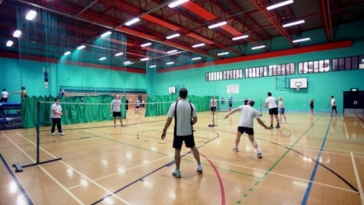
ACTIVITY
Think about the first time you joined a sports club. What values and attitudes did you have to internalise in order to function within the group??

Independent Work:
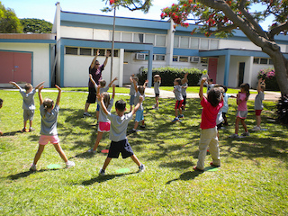
Think about and write down the various purposes of Physical Education during the secondary socialisation process
- What skills/values do children develop as a result of their PE experiences in secondary school?

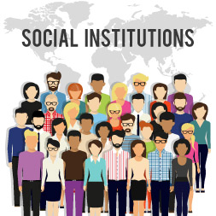
Social Control
Define it:

What are the various institutions that exist within society?

The way different institutions maintain social control within a society very much impacts an individual’s choice in relation to sport.
Task = Identify reasons why aerobics is a popular pastime among women compared to sports such as rugby.

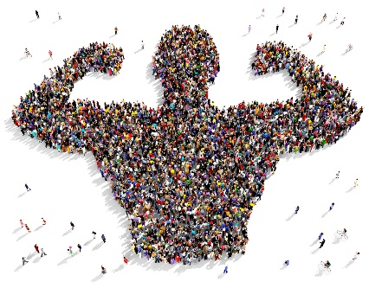
Social Change
Define it:


Sporting activities can be used in specialist programmes to try to bring about social change in a positive way.

Task = visit www.cricketforchange.org.uk/cricket-for-change/the-chris-gayle-acadmey/ and note down three key points about Cricket for Change as a scheme designed to help bring about social change.
1.

2.

3.

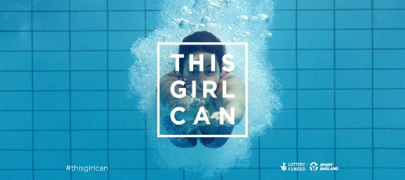
In terms of gender, the ‘This Girl Can’ campaign has been launched by Sport England as a high-profile scheme to try to bring about social changes in the way women’s participation in sport and physical activity is viewed.

Independent Work
Research a group within society that may face barriers to participation in physical activity (e.g. women, ethnic minorities).
- Investigate any initiatives that have been set up to try and change this.
- How does this link to the idea of social change?
- Produce a Poster detailing your findings

A Good poster will include:
- Information about the initiative
- Who formed it and why?
- What does is it do?
- Has it been successful?
- What are its aims?
- Pictures
- Evidence/statistics

An Excellent poster will include:
- An analysis of how it links to social change
- What more could it do reduce inequalities in sport?
- A comparison with other initiatives.

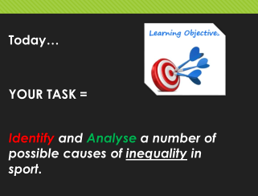
Social Issues & Inequality
Define it – Social Issues:

What is Inequality?

What are the causes of inequality in participation in sport?

Memory Tool:
You can remember key causes of inequality via MR MC!

- M
- R
- M
- C
Activity

Sport's prize money gender gap
A BBC Sport study reveals 30% of sports - including golf, cricket and squash - pay prize money that rewards men more highly than women.
The biggest disparity appears to be in football where Arsenal won both the men's and women's FA Cup this year, but while the men were given £1.8 million, Arsenal Ladies received £5,000 for their win.
Tennis is one of 25 sports where men and women receive equal prize money, and WTA chief executive Stacey Allaster says "it does not make any sense" that top female athletes in other sports are missing out on a greater share of sponsorship money and media exposure.
Watch the following video:
http://www.bbc.co.uk/sport/29786682
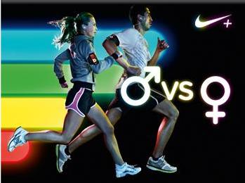
Why does this form of inequality still exist?

What could be done to change it? (think social change!)

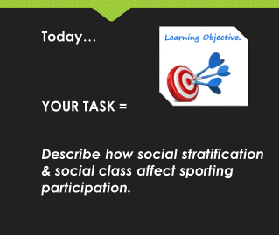
Social structures & Social stratification
Define it – Social stratification:

What social structures have an impact on a person’s access to sporting opportunities?

Identify a sporting activity linked to those from a middle- or upper middle-class group and give reasons why there is limited access to this activity for those in ‘lower’ social classes
Sporting activity: | Reasons for limited access amongst ‘lower’ classes:
Exam Question - Explain how social stratification has an impact on sporting participation: (2 marks)
________________________________________________________________________________________________________________________________________________________________________________________________________________________________________________________________________________________________________________________________________________
Social Class
A term used to define social inequalities, i.e. certain groups have more access to wealth, income and power than others. Factors which contribute to social class include a person’s job, family background, education and income.

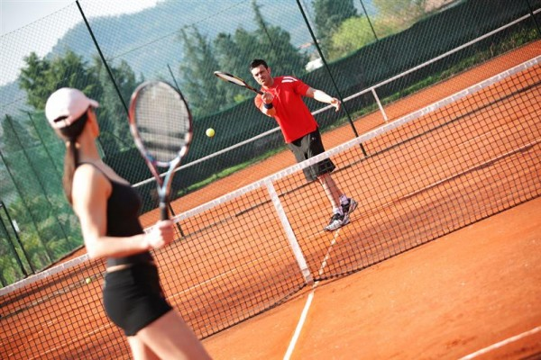
ACTIVITY – Go to page.115 in your textbook. Look at the data in Figure 1 from 2011-12 which illustrates the Sport England Active People results on sports participation linked to socio-economic groups.
What does the data illustrate to you about social class and its impact on participation in tennis?

How can participation in tennis be increased among individuals in the working class?

________________________________________________________
Independent Work
Research a sport that, similar to tennis, has a high difference in participation rate between upper-middle and lower class groups.
Why is this the case?
Think about social structures & stratification!
Provide reasons below…

What can be done to change this?
Think about social change!
Give ideas below…

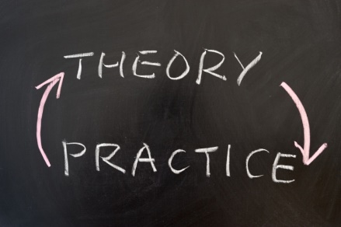
Social Action Theory
What is it?

What has it got to do with sport?

The interactionist approach
What is it?

What has it got to do with sport?

ACTIVITY:
South African World Cup winning Rugby team – 1995
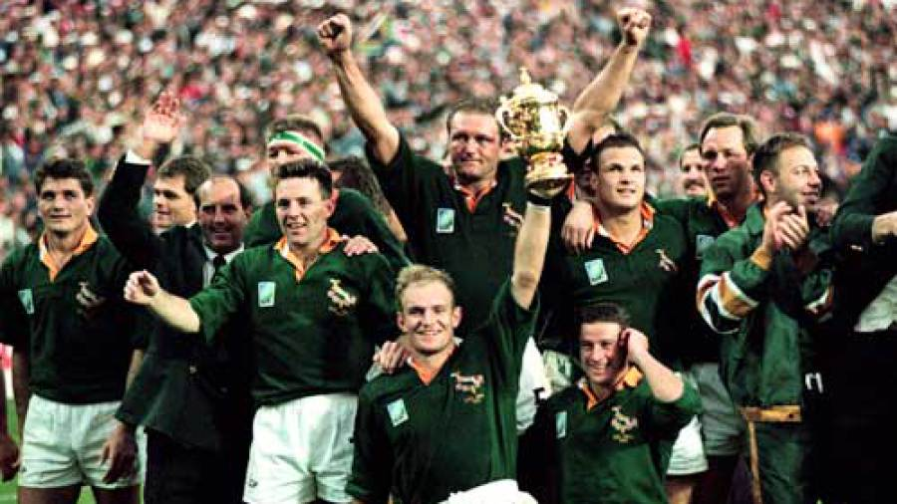
In what ways did the individuals involved change their sport?

What has this got to do with social action theory?

What has it got to do with the interactionist approach?

Key Terms
Use p. 117 to define the following key terms:

Equal opportunities:

Prejudice:

Discrimination:

What are the 2 types?

Stereotyping:

Sport England’s equality and diversity policy:

We believe that sporting opportunities should be open to all and we are committed to:
- Developing a culture that enables and values everyone’s full involvement
- Creating an environment in which everyone has opportunities to play, complete, officiate, coach, volunteer and run community sport
- Overcoming potential barriers for those wishing to pay sport, particularly if they are from groups who are currently under-represented in sport.
How are Sport England aiming to tackle some of the concepts you have just defined on p.19?

Exam-style questions
Which of the following statements best defined the term ‘socialisation’? (1 mark)
- Social mixing at a party with friends and family
- Early learning of how to behave in society
- What you learn as a teenager in adult life
- A lifelong process whereby members of society learn the values, ideas, practices and roles of that society

Define the following terms: stereotyping and prejudice. (2 marks)
________________________________________________________________________________________________________________________________________________________________________________________________________________________________________________________________________________________________________________________________

Explain how social class and social stratification affect an individual’s opportunities to take part in sport. (4 marks)
________________________________________________________________________________________________________________________________________________________________________________________________________________________________________________________________________________________________________________________________
________________________________________________________________________________________________________________________________________________________________________________________________________________________________________________________________
Teacher Feedback on Topic

