Christopher Bruce
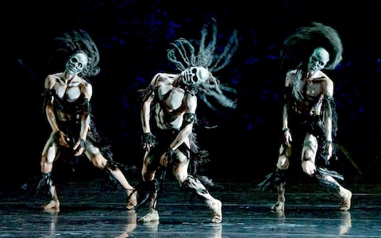
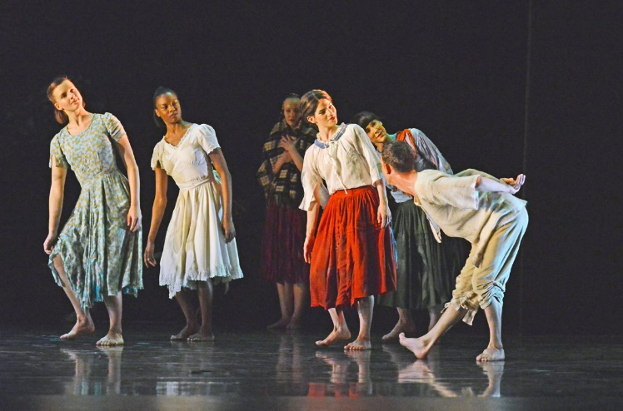

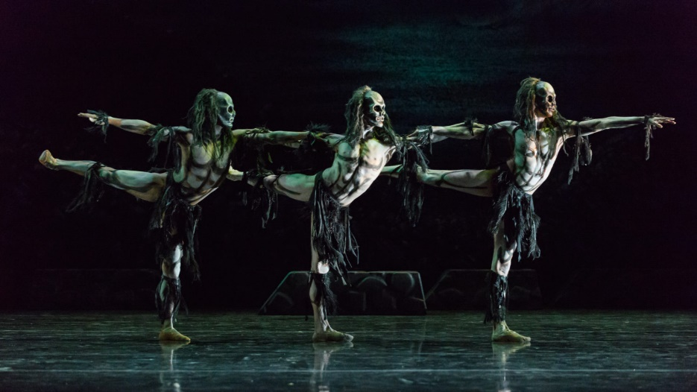

Name: …………………………………………………………………………………..

Christopher Bruce

Background (about Christopher Bruce, early life & career)

Stylistic Features

Politics & Dance

Jiri Kylian

Marie Rambert

Ghost Dances (1981)

Rooster (1991)

