A-Level Music – ‘Bridging’ Work: Y11 into Y12 Transition

(Very) Brief Overview of the Course
Component: | What do I have to do? | How much is it worth?
Component 1 | Performing:
Component 2 | Composing:
Component 3 | Appraising:

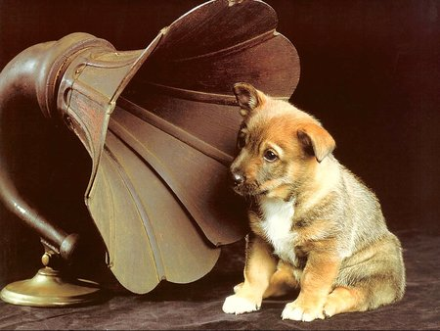
Listening Task 1
Listen to the piece and write down anything at all about the music in the space below:
___________________________________________________________
___________________________________________________________
___________________________________________________________
__________________________________________________________________________________
__________________________________________________________________________________
__________________________________________________________________________________
__________________________________________________________________________________
Using the Musical Elements
Now repeat the exercise, but this time organise your thoughts so that you describe at least one thing under each of the elements of music:
Style / Context:_____________________________________________________________________
Structure:_________________________________________________________________________
Performing Forces:__________________________________________________________________
Melody:___________________________________________________________________________
Texture:___________________________________________________________________________
Harmony:__________________________________________________________________________
Tonality:___________________________________________________________________________
Rhythm/Metre:_____________________________________________________________________

Listening Task 2:
Complete the table with your most educated guesses – be prepared to justify your choices!
 | Musical Period / Style | Possible Composer | Reason
Track 1:

Track 2:

Track 3:

Periods of Music
Fill in the information for each of the different musical periods. You may need to research to find out some of this information, but please aim to do as much as you can independently first.
The Renaissance Period
Dates:
Composers:
Key Features
Instruments used:

The Baroque Period
Dates:
Composers:
Key Features
Instruments used:

The Classical Period
Dates:
Composers:
Key Features
Instruments used:

The Romantic Period
Dates:
Composers:
Key Features
Instruments used:

The Modern / 20th Century Period
Dates:
Composers:
Key Features
Instruments used:

Finally… Get to Know Your Set Works

Vocal Music | ● J. S. Bach, Cantata, Ein feste Burg  ● Vaughan Williams, On Wenlock Edge
Instrumental Music | ● Clara Wieck-Schumann, Piano Trio in G minor, Op. 17: movement 1  ● Berlioz, Symphonie Fantastique
Music for Film | ● Danny Elfman, Batman Returns  ● Bernard Herrmann, Psycho
Popular Music and Jazz | ● Courtney Pine, Back in the Day  ● Kate Bush, Hounds of Love  ● Beatles, Revolver
Fusions Music | ● Debussy, Estampes  ● Anoushka Shankar, Breathing Under Water
New Directions | ● Kaija Saariaho, Petals for Violoncello and Live Electronics  ● Stravinsky, The Rite of Spring

You will need to know everything there is to know about these pieces, so the more you listen to them and research them now, the better!
Researching specific works involves finding out about the composers and the context of each piece, as well as listening to other similar works / artists to find out how they each fit into their respective genres.
It is therefore very good practice for you to listen to as much music as you can before and during your A-Level Music course. Broaden your musical horizons by branching into new styles and open your mind to artists you wouldn’t necessarily normally listen to – you might find something surprising!

