e D of E help sheet
Your Expedition section will be completed for you by Mrs Price- please leave this section
The remaining 3 sections that must be completed by you to achieve the award are-
- Volunteering
- Skills
- Physical

- For each section you need to input your programme planner (the activity you are doing, the timescales and who your assessor is going to be- please put their full name if possible and a contact). You then need to submit your programme planner to Mrs Price.

- For each section you also need to have an assessor report. The easiest way of doing this is asking your assessor to fill in your assessor card booklet and then taking a photo and uploading it in to the correct section. When you submit it make sure you mark it as an assessor report. Your assessor booklet has been posted to you from D of E when you inputted your home address on e D of E. if you need another copy, they are on the school D of E Website. https://www.ttsonline.net/Uploads/documents/DukeBronzeInfo/dofe-Assessor-cards-BRONZE-ENGLISH.pdf
These are examples of the assessor cards for each section you will be sent. They are in a booklet-
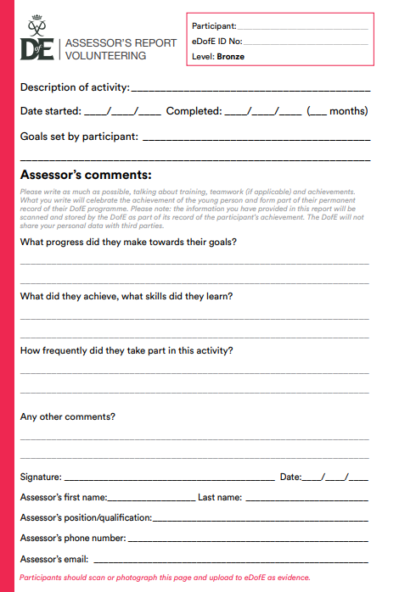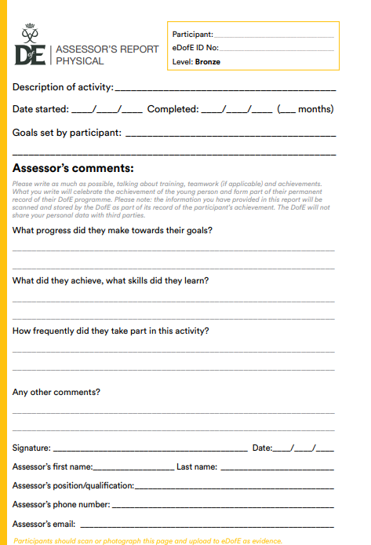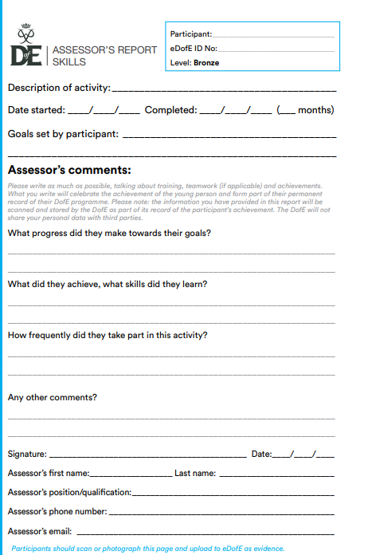

- Your assessor can submit your assessor report online- https://edofe.org/Assessor . If choosing this way was then your assessor must include the start and end date, state that you did an hour a week and then put their full name and contact at the end of the report.
Once all of the above have been completed, your award will be sent off to the verifier and then your certificate will be presented in assembly.
Completion Checklist
Section | Area | Completed  
Volunteering | Programme Planner
Volunteering | Uploaded an assessor report
Skills | Programme Planner
Skills | Uploaded an assessor report
Physical | Programme Planner
Physical | Uploaded an assessor report

